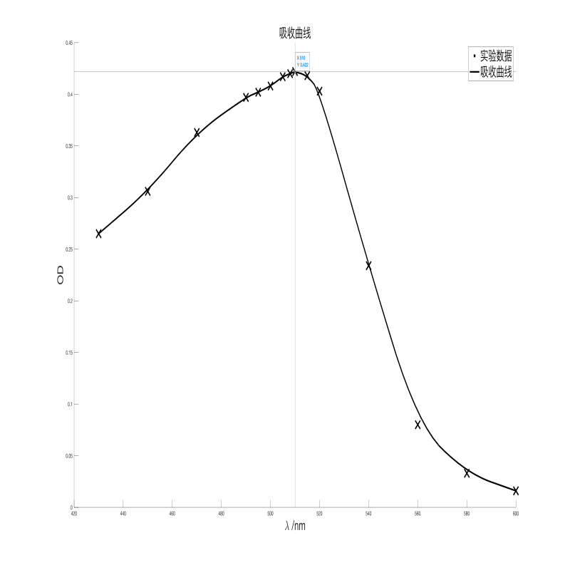

|  |  |
| --- | --- |
| λ | ODλ |
| 430 | 0.265 |
| 450 | 0.306 |
| 470 | 0.363 |
| 490 | 0.397 |
| 495 | 0.402 |
| 500 | 0.408 |
| 505 | 0.417 |
| 508 | 0.42 |
| 510 | 0.422 |
| 515 | 0.418 |
| 520 | 0.403 |
| 540 | 0.234 |
| 560 | 0.08 |
| 580 | 0.033 |
| 600 | 0.016 |

取λ=510 nm

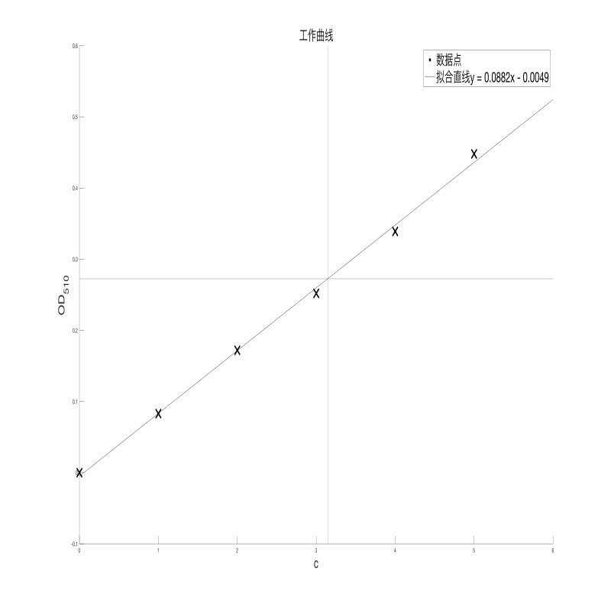

|  |  |
| --- | --- |
| c | OD510 |
| 0 | 0 |
| 1 | 0.083 |
| 2 | 0.172 |
| 3 | 0.252 |
| 4 | 0.339 |
| 5 | 0.448 |

OD510=0.2725时，相对c=3.14512

每3.5 mL样品含3.14512 mL×0.010 mg/mL=3.1451E-2 mg Fe

第二次稀释总Fe 2.2465 mg

第一次稀释总Fe 28.081 mg

即样品含Fe 28.081 mg

Fe含量为28.081/255.6=10.99%